Q1)

Find the differential gain in the figure (1), differential input resistance, common mode gain, and the common mode in put resistance.

(Assume the Early voltage=100v)

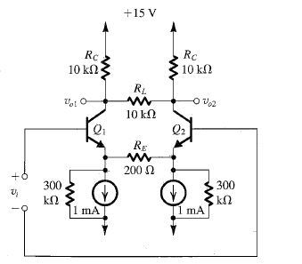

Fig.1

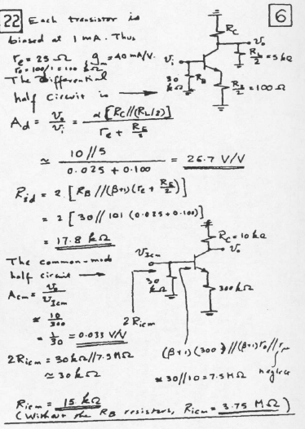

Q2)

A differential amplifier is fed in a balanced or push pull manner with the source resistance in series with each base being Rs. show that a mismatch ΔRs between the values of the two source resistance gives rise to an input offset voltage of approximately (1/2β) ΔRs

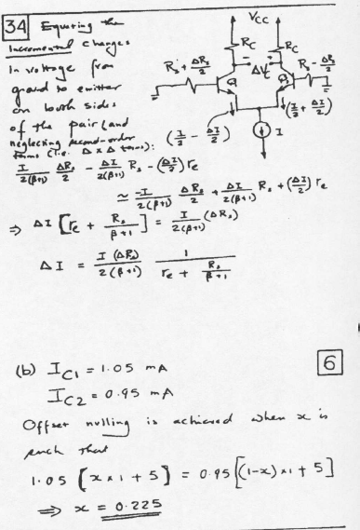

Q3)

Differential pair .here .Q1and Q2 from the differential pair , whereas Q3 is an emitter follower that performs two function it shifts the level of the output voltage to make Vout and Vol centered on the reference voltage Vg thus enabling one gate to drive another and it provides the inverter with a low output resistance .all transistors have VBE=0.7 at Ic=1mA

(a) For Vi sufficiently low that Q1 is cut off , find the value of the output voltage Vo. This is VoH.

(b) For Vi sufficiently high that Q1 is carrying, all the current *I*, find the value of the output voltage Vo. This is Vo*l*

(c) Determine the value of Vi that results in Q1 conducting 1% of *I*. This can be taken as VI*l*.

(d) Determine the value of Vi that results in Q1 conducting 99% of *I*. This can be taken as VIH.

(e) Sketch and clearly label the breakpoints of the inverter voltage transfer characteristic. Calculate the values of the noise margins NMH

NM*l ,* note the junction choice of the value of the reference voltage VR

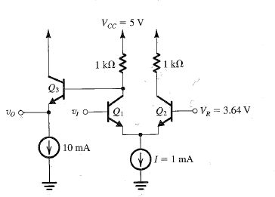

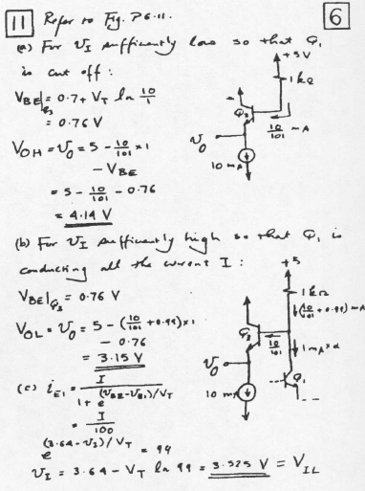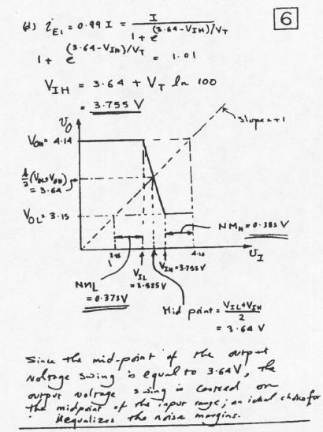

Q4) Find the voltage gain and input resistance of the amplifier in figure (2).

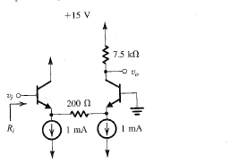

Fig.2

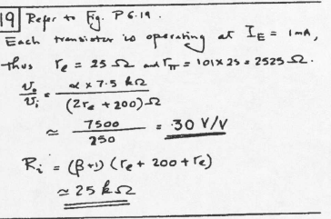

Q5)

a) Draw and Compare between Wilson CM and Wildar CM

b) Prove the expression for the current transfer ratio of the Wilson CM

c) Prove the expression for the current transfer ratio of the Wildar CM

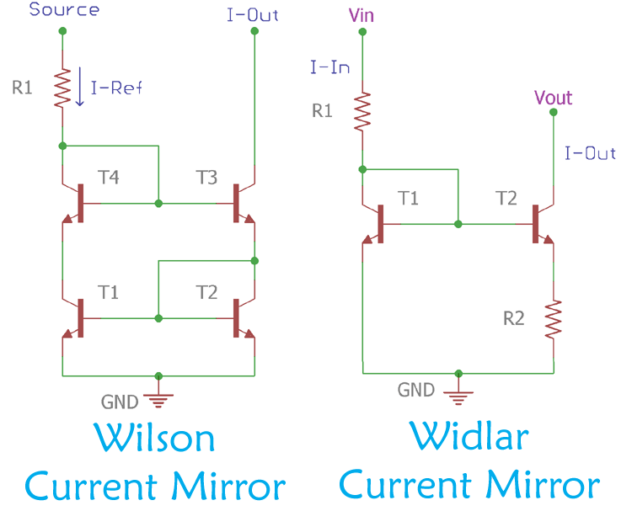

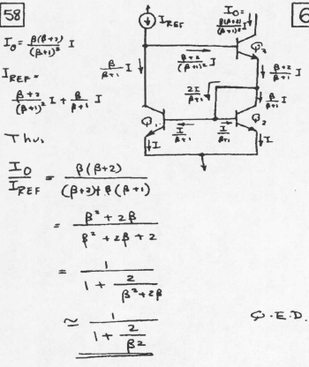

Solution (c) in lecture current source

Q6)

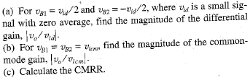



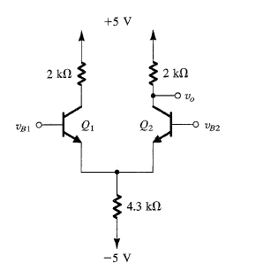

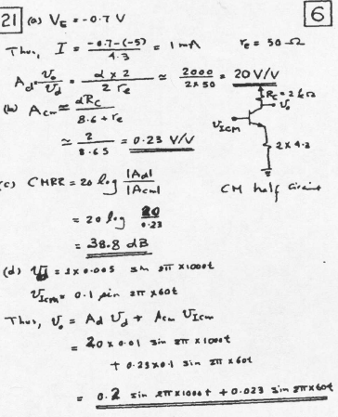

Q7)

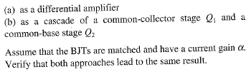

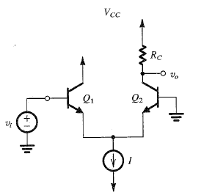

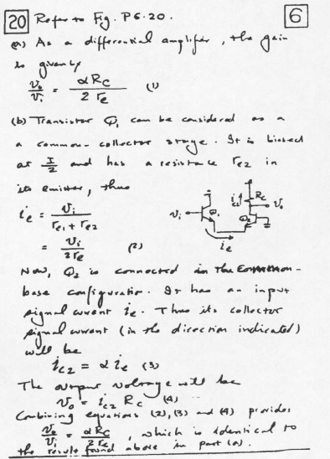

Q8)

Find the voltage gain and the input resistance of the amplifier shown in figure

